CSE 555 Project

Group DAGS

Supplementary Images for the project

We trained multiple ML and DL models on the six types of MNIST dataset (Original, Balanced, Asymmetric Balanced, Asymmetric Imbalanced, Symmetric Balanced, Symmetric Imbalanced) for the completion of our project.

In this file we provide some images showing the performance of the various models.

We have shown the confusion matrix along with the Training and Validation Loss graphs for the DL models and Precision vs Recall and ROC curve for the ML models.

LDAM-DRW

Original Balanced Dataset:

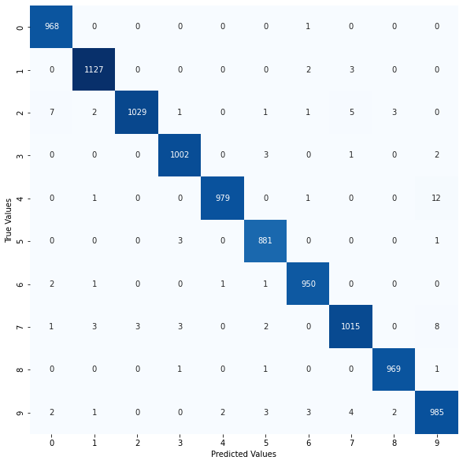

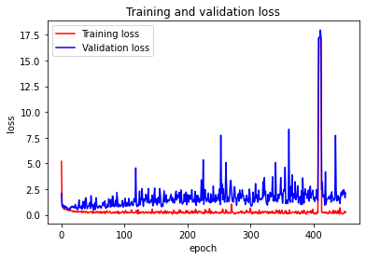

Original Imbalanced Dataset:

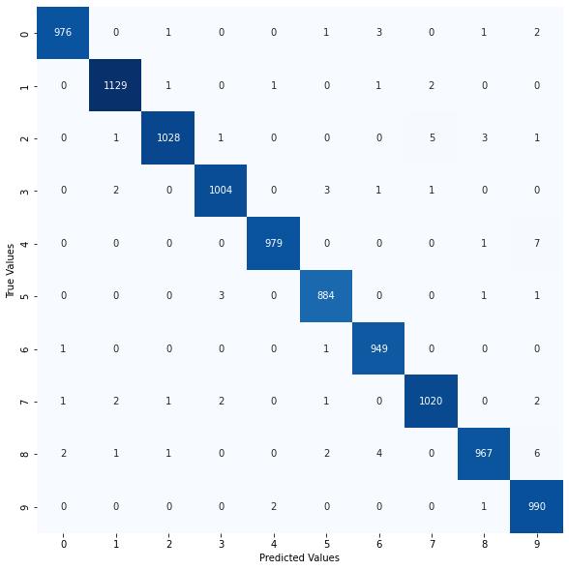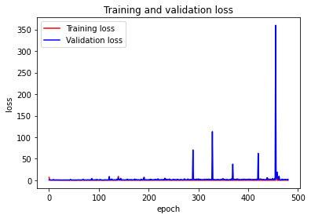

Balanced Symmetric Dataset:

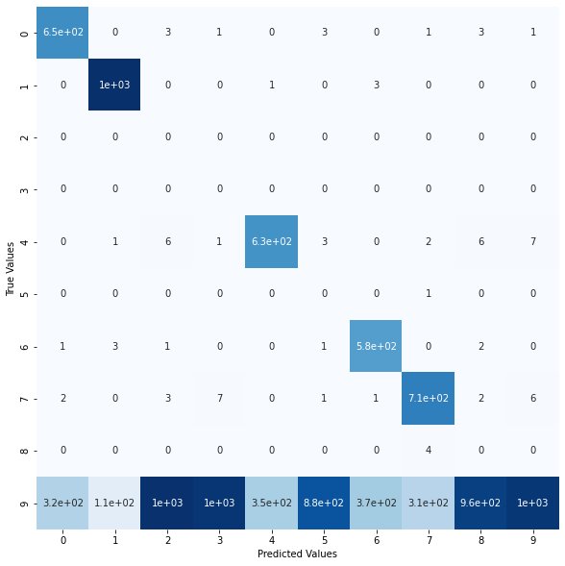

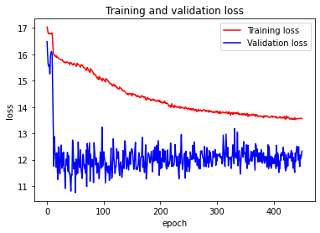

Imbalanced Symmetric Dataset:

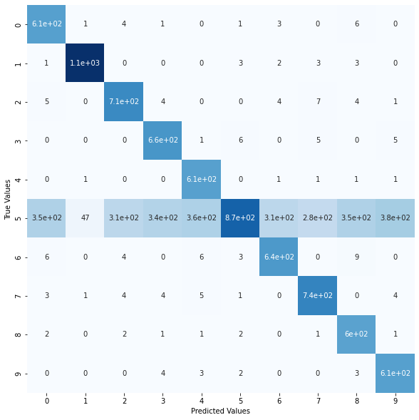

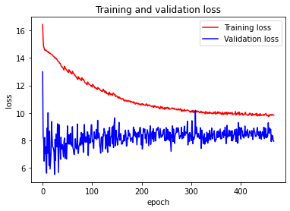

Balanced Asymmetric Dataset:

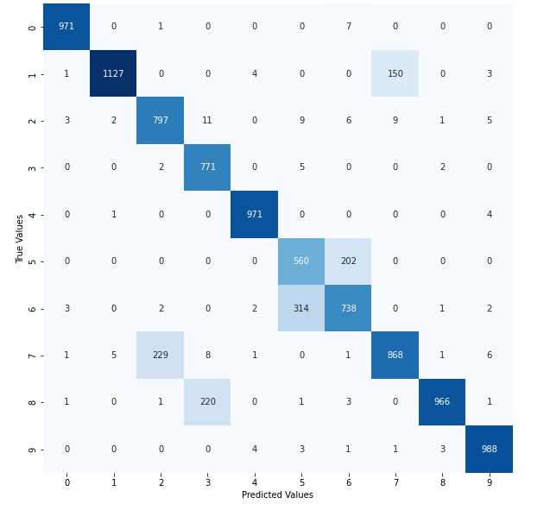

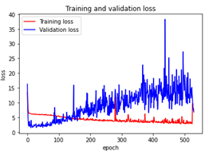

Imbalanced Asymmetric Dataset:

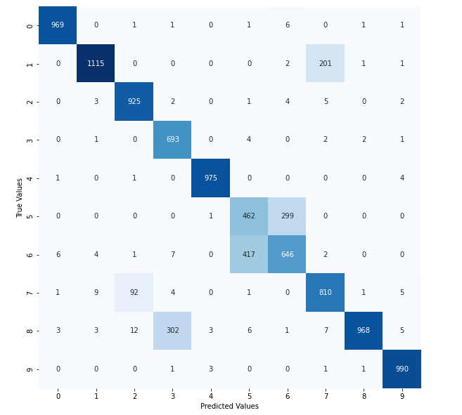

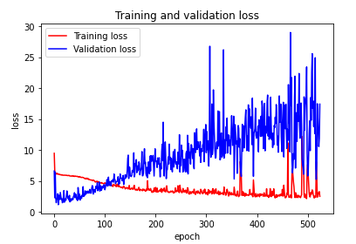

Symmetric Learning

Original (Imbalanced) Dataset:

Balanced Dataset:

Symmetric Balanced Dataset:

Asymmetric Balanced Dataset:

Symmetric Imbalanced:

Asymmetric Imbalanced Dataset:

Normalized SL (Proposed Model)

Original (Imbalanced) Dataset:

Original Balanced Dataset:

Asymmetric Imbalanced Dataset:

Asymmetric Balanced Dataset:

Symmetric Balanced Dataset:

Symmetric Balanced Dataset:

PCA+ KNN (Proposed ML)

Original (Imbalanced) Dataset:

Balanced Dataset:

Imbalanced Asymmetric Dataset:

Balanced Symmetric Dataset:

Balanced Asymmetric Dataset:

Imbalanced Asymmetric Dataset:

Logistic Regression

Original (Imbalanced) Dataset:

Balanced Dataset:

Imbalanced Symmetric Dataset:

Imbalanced Asymmetric Dataset:

Balanced Symmetric Dataset:

Balanced Asymmetric Dataset:

SVM

Original (Imbalanced) Dataset:

Balanced Dataset:

Imbalanced Asymmetric Dataset:

Balanced Symmetric Dataset:

Imbalanced Symmetric Dataset:

